Schedule
7:00 am | Lights come on, cells open. I dress and brush my teeth. Country music videos start the day on the day room TV. Midmorning, the soundtrack switches to MTV.
7:30 am | Breakfast in the day room
8:00 am | Laundry is picked up. The item of the day rotates.
9:00 am | Meds are brought for those that take them
Noon | Lunch in the day room
1:00 pm-ish | Meds
2:30 pm | Lockdown for an hour. You are in your cell, no day room. I use this for my first workout.
5:00 pm | Dinner in the day room
9:00 pm | Meds
10:00 pm | Lockdown for the night. Workout #2 for me.
11:00 pm | Lights dimmed for sleeping

For a place with time as the most abundant commodity, I am surprised at how well managed it is.

Letter 1
1-8-26
“Don’t drop the soap” is a phrase that probably everyone hears in middle school. Well, at least I did.
I doubt we really understood the implication then, but as we got older, we understood it to also be a warning to not go to prison.
Luckily, there is a difference between prison and county jail. Prison makes for better TV. This, county jail, is the entertainment equivalent of the TV Guide channel. I’m okay with that.
The shower area occupies a room off of the day room, separated by a curtain. The area is then subdivided by a curtain that keeps the changing area from being completely soaked by the actual shower.
The shower itself has good pressure and, most days, good temperature. Its biggest issue is that it operates by a push button that activates 10 seconds of water. This leaves the options of intermittent water, a constant 10-second countdown running in your mind, or ideally just giving the button an extra press every few seconds. In theory, it’s pretty easy to press the button between soaping or rinsing and have a steady, constant stream of water. In practice, however, it’s a bit more of a juggling act than I anticipated. This led the soap to play the role of an excited otter, eager to escape my grasp and slip into the water, splashing about and actively avoiding capture.
Fortunately, this isn’t prison as seen on TV, otherwise I’m not sure I’d be able to sit down to write this.

Letter 2
1-9-26
For some reason, beyond the people I see every day, this jail is low on money. You can see it in the short staff and the issues that it causes. You can also see it in the linens. Quite literally. The sheets, towels, and blankets all have the qualities of a used, tattered coffee filter, both in structure and color.
Another area that could use an influx of love is the bookshelf. I’m certain this is a low priority for the overall budget, but I do feel that this is an area where a local non-profit could really help. ;)
Despite any other shortcomings, I am surprised at how much I have enjoyed the meals.
Before arriving, I allowed myself a pretty unlimited garbage diet. I figured this would be an easy place to practice some dietary discipline. By not ordering supplemental snacks from the commissary, I would by default be limited to the 3 served meals each day.
The self-discipline has been easy. Since I’m not in control of much, I can at least be in charge of what I consume. The hard part is determining whether the food is good, or if I’m just hungry!
Whoever is in charge of the menu seems to do an excellent job with variety and flavor. However, today I found myself eating a mix of peas, green beans, and corn. There is no possible way they somehow made that into a tasty combo, so I must assume I am either hungry enough to enjoy it or I have the discerning palate of a possum with COVID. Perhaps both.

Letter 3
1-14-26
I have included a map to help illustrate my letters. In my head, it’s the map at the beginning of an adventure novel.
It’s drawn pretty close to scale. The cell wall is about 28 feet long and looks like a section of any motel in America: 4 doors on the bottom floor, with 4 identical doors above them. In front of the upper doors is a walkway I have generously labeled a balcony.
There are 3 stars. These are where I spend 90% of my day.
First, my cell. Actually number 163, but #1 on here. In a different letter, I will detail this. Next is my favorite chair location. Here I will pull up a plastic chair for my ass and use the built-in seat of the 4-top for my feet. Lastly is my seat on the picnic table bench for meal times.
The TV is on a high shelf above the phones. Visually, you are on display while on the phone, but the noise of the TV drowns out most eavesdropping.
The dayroom/common area has 4 walls, but all of differing lengths. I don’t remember all of my high school geometry, but I’m pretty sure that 4 uneven sides, specifically in a jail, are a crapazoid.
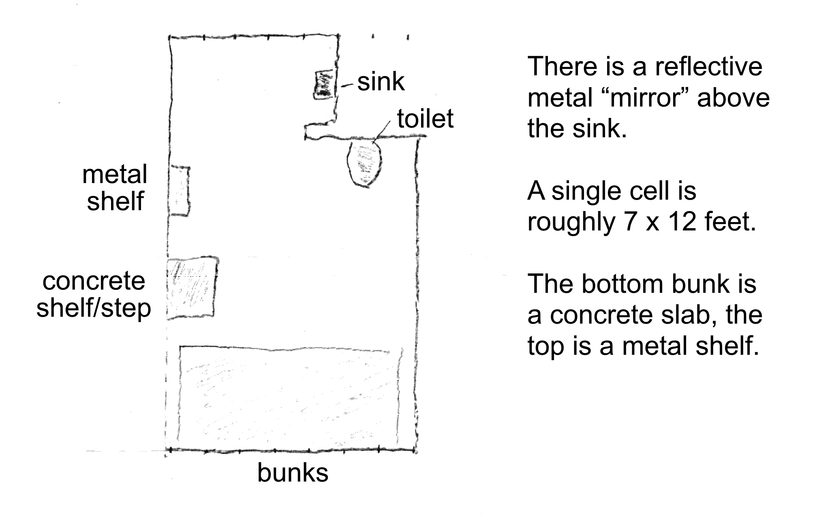
There are 8 plastic chairs: 4 coveted ones with arms, and 4 without. One of the armless ones spends most of its time in the shower changing area.

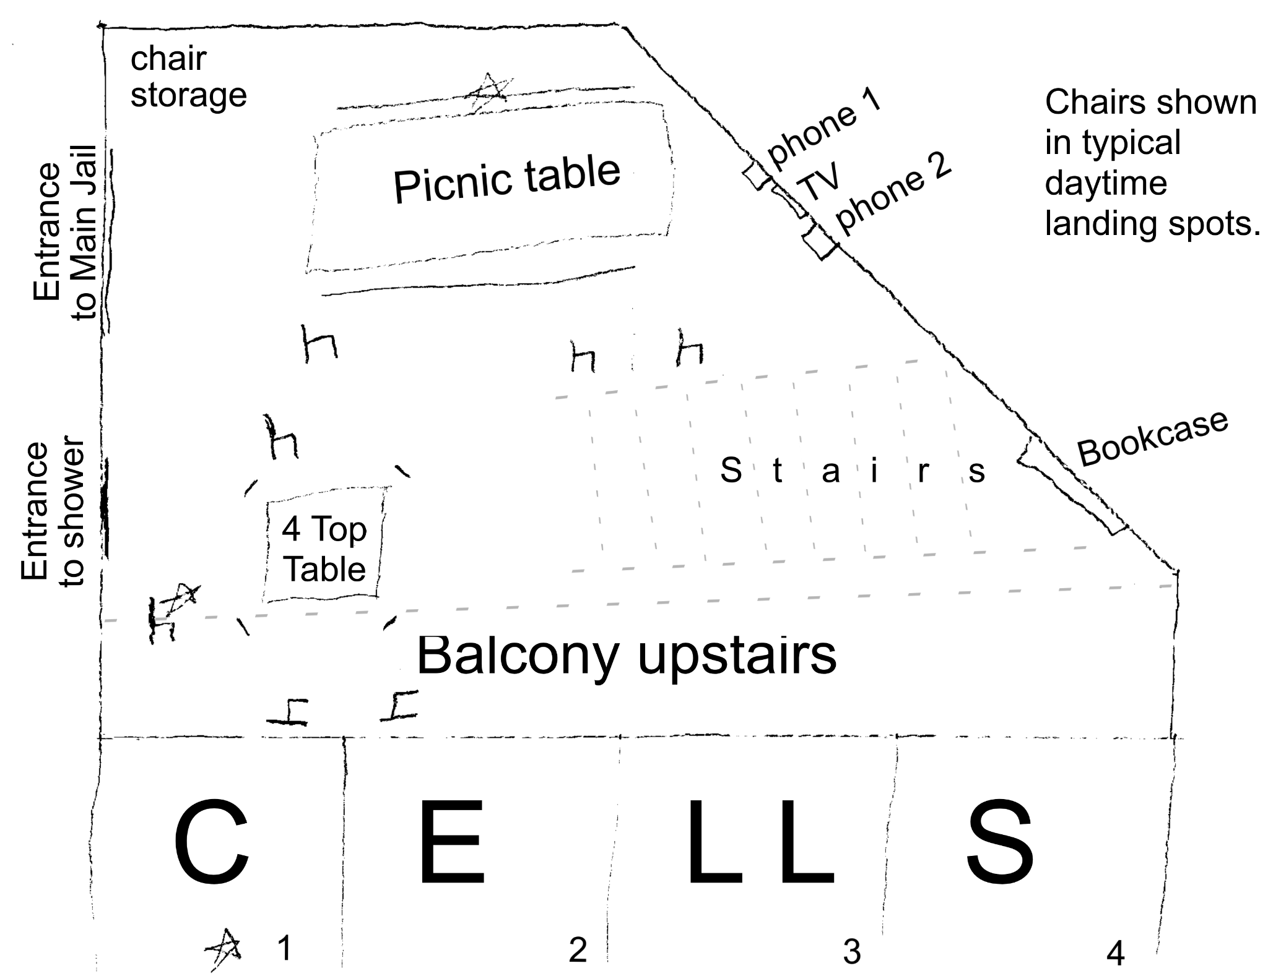

Letter 4
1-15-26
Growing up in the woods of Northern Maine, we got our water from a well in the yard. Not the kind of well with a bucket or hand pump, but a well drilled into the ground and fitted with an electric pump that sent water on demand to our pipes inside.
I can’t describe the flavor other than to say it’s the way water is supposed to taste. It’s pure and crisp. I imagine it’s the taste of the nearly untouched wilderness, combined with just a hint of moose piss that’s been filtered through layers of rich soil and ancient rocks. The recipe for the best water on the planet.
Since I have moved away, I have been unable to enjoy tap water. Even the best tap water seems to have been scooped directly from a swimming pool. The best I have found is ice-cold bottled water. Even then, though, I prefer to flavor that water with packets of flavor that dye the water a random color pulled from an unholy neon rainbow.
Between bottles of water, drink mixes, too many energy drinks, and daily coffee, I had my hydration system figured out. That is, until I arrived here.
I’m not one hundred percent certain, but I believe the water here was stolen from the shower drain, poorly filtered through an old sock, and served through a rusty pipe.
I do not drink alcohol. The times I tried a sip in an attempt to look cool, my face scrunched up in an expression that betrayed my lack of cool. I made that same lemon-sucking expression upon trying the water here.
For two days I drank only the few ounces of juice, punch, or iced tea that came with meals.
The dehydration and caffeine withdrawal were really the worst parts of my first few days.
Luckily, relief came in the form of three tea bags, generously offered by someone on the cell block. Three tea bags, steeped in cold water in a plastic tumbler, created an elixir close enough to iced tea that I hung onto those 3 tea bags for two days, until I had extracted every ounce of water-altering flavor out of them.
Today, my first commissary order finally arrived. I have been blessed with over 100 tea bags, in two different flavors. I doubt I will be able to recreate much variety with this, but I am grateful for the opportunity to try.
Sometimes it takes effort to find things to be grateful for, but it is effort well spent.

Letter 5
1-17-26
There is an old guy on my block. Short gray hair, and looks like he’s been on the losing end of the battle of the bulge for a few years. He’s probably about my age.
He’s quiet and keeps to himself. He just passed his one-year anniversary of being here. I’m not sure what his full story is, and it’s not polite to ask. I do know that he has “been upstate,” meaning a state prison. He seems content to keep his head down and peacefully ride out his remaining time here.
Old Guy has claimed a spot next to my cell door where he sets up a chair every day. That particular location affords him the opportunity to see through a gap in our main door that connects our block to the rest of the jail. From this vantage point, he has advanced warning of a few things, most notably, chow time.
A few minutes before each meal, he announces, “Chow’s on C.” This means that he can see the cart that carries our meals is currently at C Block. We know that we are next. This is our signal to pack up what we are doing, put our chairs away, and start lining up.
His next announcement, in his self-appointed duty, is “Chow’s up.” This lets the rest of us know to finish lining up. The meal cart is at our door.
There isn’t much jockeying for position in line. It’s first come, first served, but the meals are identical and handed out rapidly, so there is no rush. The one exception is that Old Guy always finds a spot in line behind me. After almost spilling my first two meals on him as I slid past him to my seat, it was silently agreed upon that I should get to my seat first.
The seats aren’t assigned, but once you claim a seat, it’s yours for every meal. We have sturdy plastic chairs that we can move about the day room, but those aren’t used for meals. Instead, we have two stainless steel picnic tables bolted to the floor. The long one is pretty much used exclusively for meals. The square four-top is used for meals and card games.
Once we are seated, the experience reminds me of chimpanzee grooming behavior. Researchers call it a Biological Marketplace Model! Chimps trade grooming as a form of social currency. Because the act of grooming another member of the troop requires time and energy, it is considered a resource among the chimps. Typically, they spend this resource with the unspoken contract, “If I invest time and energy in you, you are more likely to support me later.”
Sometimes this takes the form of lower-ranking males offering exchange for high rank males intervening on their behalf in conflict, allowing access to other resources, or merely just tolerating their presence. Sometimes ambitious males use it tactically to form alliances and negotiate status.
Here we discover we are not that far removed from the chimps. However, instead of grooming, we are all handed the resource of food. Everyone is welcome to eat all of the food that they want from their own tray and turn the leftovers in when they are done.
Just like the chimps, though, this resource can be traded as a social currency. Very seldom is it a one-for-one trade (like an elementary school lunch room may be). I don’t see transactions such as, “I will trade you my slice of cake for your french fries.” Instead, the cake is offered up with the unspoken understanding that something will be offered in return at some point in the future.
Perhaps the reciprocal offering will indeed be french fries at a later date. Perhaps it will be something less tangible, such as a seat at the table while playing cards, or the prevention of future harassment.
I am too fond of my desserts to offer them up for anything. I am too aware of my nutritional needs to offer up my veggies or protein. This has left me with one leftover resource: the 8-ounce carton of milk supplied with every breakfast.
I have chosen Chimpman as the recipient of my generosity. He is a low-ranked male within the troop and does not have many existing social contracts. My distaste for milk has led to attempts to lock him into our own unspoken contract.
Today this paid off as he looked at me, with his overgrown beard and too-long, disheveled hair, and handed me his coconut brownie.
Tick-free and brownie rich, I am a satisfied chimp.
Letter 6
1-25-26
There was a time that I trained Jiu-jitsu with Steve. He was skilled, but very unassuming in appearance. He was tall, but also a skinny lightweight. Despite his skill, nobody looked at him and assumed he was dangerous.
This led to a phenomenon that we affectionately called “Steve’s a Bitch Syndrome.” For years, when a new person started training and wanted to prove themselves, they would look around the room and pick the match they figured they would win. Their eyes typically landed on Steve, and you could almost hear their thoughts as they decided, “That guy looks like a bitch.” Steve would ultimately put the new guy in their place, and things were good until the next new guy arrived.
I saw a similar event here the other day. A young inmate felt the need to prove himself and looked around the room for the easiest match. The result was pretty uneventful, culminating in some shouting and the young inmate giving a small shove to his target. It did not escalate into an actual fight, but it did lead to the young inmate being removed from the block and locked down by himself.
Over the years, I have noticed that in a lot of environments, the fiercest competition happens at the bottom of the food chain. Don’t get me wrong, there is plenty of healthy rivalry for the top spot in every room, but this can be more of a subtle and prolonged struggle.
The claws really come out when someone fears that they are in the bottom spot and they don’t want to accept it. Like an episode of Survivor, they don’t want to be last, the one voted off the island.

Letter 7
1-26-26
Toilet Paper
As a kid, most of my jeans had holes in the knees. The near-constant friction of the denim on carpet as I played with my toys wore the fabric thin.
I had G.I. Joe soldiers, Lego figures, and 2-inch wrestlers that I had countless adventures with. They played roles of pirates, townsfolk, and the crew of the USS Enterprise, along with whatever else I could imagine.
A lot of these adventures required trees, secret tunnels, and sewer pipes. Fortunately, our family of four had a near-endless supply of these in the form of toilet paper tubes. These cardboard tubes were collected and hoarded like precious gems.
Now, about four decades later, I find myself once again coveting these priceless cylinders.
You see, in order to receive a new roll of toilet paper, you must turn in an old tube during the twice-weekly ceremony.
Sara’s first thought was that they were attempting to prevent us from literally “crafting” an escape, but I’m fairly certain it’s because they don’t want us to hoard supplies. None of us really need two rolls per week, but we would all take them if offered, so the exchange program was developed by some overburdened warden from days long in the past.
Of course, we, the inmates, have nothing but time, and apparently an endless desire for a secret stash of toilet paper. Twice per week, a guard appears with a fresh stock of rolls. Without fail, every single inmate appears with an empty roll.
There has never been a meeting of the “Orange Clad 2-Ply Collectors Club,” but we have all individually figured out a way to make an empty roll appear after three days.
Personally, I prefer to extract my tube from a full roll as soon as possible. Paranoid of theft, I would much rather lose the paper (because it obviously has extra) than that valuable core that I have secreted away like the treasure that I have always known it was.

Letter 8
1-30-26
I wake up, but don’t open my eyes.
At some point in my life, probably after reading an adventure novel, I trained myself to not open my eyes until I was sure of where I was. This would be very useful if captured by a master villain that was waiting for me to wake up so he could interrogate me. As it turns out, this scenario has occurred as often as I have encountered quicksand.
With my eyes closed, I listen. I can hear the murmurs of people talking, the sound of the TV in the background, and yet another announcement over the intercom. I am still here, still waiting.
As I look around, I see people waiting for their flights, all scheduled to depart before mine. Half of them have a firm departure time. The rest only have a vague window. For now, though, we are all in the same place, waiting.
I am trying not to overhear one guy on the phone. Clearly, the events here are not the worst part of his day, but this probably isn’t helping either. I wouldn’t mind talking to someone to pass the time, but I have no desire to be his therapist when he will inevitably want to vent about whatever is happening on the other end of the phone.
There are people attempting to sleep, even though it’s the middle of the day. I am tempted by this option, but instead choose to attempt to save my sleepiness for when night comes and there is nothing to do but sleep. Besides, this airport terminal is designed for warehousing people, not for comfort. So joining the ranks of those trying to find rest on a concrete slab, while using their spare clothing as a pillow, is not as attractive an option as it first seems.
Not long ago, a security team was here to remove an unruly passenger. He was frustrated with waiting and wanted to loudly voice his displeasure with the crew here. Even though the terminal crew has no impact on wait times or how the rest of the system functions, they seem to get a lot of the grief just because they are seen as part of the same system that disappoints us all.
I pull out my tablet to pass the next hour. There is no outside internet available. I need to connect to the local Wi-Fi. Normally this isn’t an issue, but the internal Wi-Fi costs 3 cents per minute to access. It’s an annoying fee, but to keep in touch with work, send some messages, and for a little forget where I am, it’s well worth it.
I glance over my screen and spy someone finishing a book. I feel like I just might ask to borrow it. I listen to audiobooks all the time at home, but I haven’t turned a paper page in years. With the limited options of activities here, that’s probably going to occupy a lot of my time.
I’m hungry, but this terminal only offers one food option. It’s a decent cafeteria, but it is currently closed. There is the typical airport convenience store, but I refuse to get a snack from there. I tell myself that my refusal is due to the lack of healthy options. However, their predatory pricing, targeting a captive audience, fuels my stubbornness.
The TV is still playing, but fails to capture my attention. The Discovery Channel show about living in Alaska, or mining gold, seems like it has been on since I got here.
I turn off the tablet I’m not actually using anyway. I take one last look around before I close my eyes for the nap I refuse to take.
We all come from different places and are headed to different destinations, but for right now, in this place, we are all the same. Together, we wait.

Letter 10
2-9-26
Spending Time
There is a category of phone game that is called “Freemium.” With these, you can download the basic game for free. However, if you want access to the premium version, with all the good features, you need to either pay an upgrade fee or make purchases within the game.
I’m not sure who had the idea first, but jail seems to have been designed with the same model. Everyone who comes in gets access to the basic, free version. You soon discover, though, that the premium features cost extra.
For our convenience, when we arrive, any cash we have is automatically put into a commissary account, minus a $50 booking fee, of course. When you need to add to this account, there are a few ways for your friends and family to make deposits on your behalf, for a three to five percent fee.
If you have insufficient funds, they will still allow you prescriptions and haircuts. Your account will just go negative until funds are added or you leave, whichever comes first.
If you have a positive balance, then you have access to the weekly commissary ordering system. This is a list of about 250 items that you don’t “need” to stay alive, but you probably want to live.
We are provided three meals per day, but if those meals don’t cut it for you in some way, that’s where commissary comes in. It is less of a supermarket and more of a convenience store, both in selection and price. You can find a variety of snacks, such as small bags of chips, meat sticks, candy, or the ever-popular pack of ramen (available for $1.15 per pack).
For me, I find the drink section invaluable for masking the taste of the god-awful water. I get coffee and tea (both prepared in-cell with lukewarm to cold water) and sugar-free orange and black cherry flavor packets.
All of us are provided free toiletries. These are of the quality as provided by a cheap motel that resents the fact that customers expect soap and shampoo. So, if you want deodorant that works, Q-tips, Tums, chapstick, etc., the commissary is there for you.
The part of the commissary list that I find the most predatory is the clothing section. When you arrive, you are issued orange scrubs, a pair of shower shoes, and a pair of rubber-soled slippers. If you happen to be wearing socks, underwear, or a bra when you arrive, you can keep those with you. If you are the type of person that needs more than one pair of socks or underwear, and you have money on your books, commissary is there for you.
If you happen to be made of flesh and blood, you will find the temperature within these concrete walls rather chilly. You need not fret, though; commissary is there with T-shirts and thermal undergarments, if you can afford them. These items are necessary enough that those who can’t afford them are constantly hoping for donations from departing inmates. These well-used, grungy hand-me-downs are gratefully accepted as ill-fitting armor against an HVAC system that seems specifically designed for discomfort.
Once your physical needs are taken care of, you can look to psychological ones. You are permitted one free 5-minute call per month. Any additional calls cost twenty-five cents per minute. For our convenience, this fee can be paid from our commissary account, or by the gracious soul on the other end of the line.
In an effort to extract money in the most modern way possible, we have also been granted access to a limited number of electronic tablets. Similar to an iPad handed to unruly toddlers, these are securely encased in rubber and locked with a number of parental controls. Once someone on the outside adds money to your tablet account, which is a different, less flexible bank of funds, you are allowed to utilize a suite of electronic funds and apps.
There is a messaging app that is nearly identical to texting. There are two differences between this app and modern texting as we know it. First, our protective Big Brother uses an algorithm to monitor all text, and human eyes to approve all pictures. Then, there is, of course, the fees. It charges the inmate three cents per minute to be logged in. So every minute of reading, writing, and pondering both incoming and outgoing messages eats away at the current balance. Then, because they can, there is also a fee of twenty-five cents per message that is sent from the outside. This fee is deducted from yet another account, one set up by the outside contact.
All of this combines to leave me conflicted. On the one hand, I am grateful for the opportunity to access basic comforts and communications. On the other hand, I expected more “doing time” and less “spending time.”

Letter 11
2-10-26
$$
In the criminal justice system, the people are divided into two separate and completely unequal groups: those that have money, and those that do not.
Dun-dun.
I feel like day-to-day life is like a “freemium” game. These are often found in the “free” section of a phone’s download store. Everyone starts with the base version of the game, but you can unlock more features if you pay for them. I think the commissary system is an example of that.
On a larger scale, though, I feel like the entire system is “pay to win.” These video games, often played online against strangers, pretend that everyone has access to the full game. While that is technically true, those that buy the best upgrades and gear in the game have a distinct advantage.
Everyone in a “pay to win” game plays in the same arena. Everyone even has access to all the same gear. However, you can choose to either earn that virtual gun with hours of gameplay, or skip to the front of the line and buy it with cash. Then do the same for the virtual boots, then the pants, then the gloves, on and on. The claim is that the system is fair because everyone has equal access to all the gear. In practice, though, it’s those that buy their way to the top that win.
Here, it is no different. It starts the day that you are arrested. Everyone is given the same options: pay your bail amount, or sit in jail until trial. If you already have money, then you have a choice. If you don’t have money, the choice is made for you.
Being able to pay my bail meant I had bought the freedom to spend the next 10 months working and preparing myself, my family, and my job for the time away.
If you cannot afford a lawyer, one will be provided for you. While this is true, the public defender makes exactly the same paycheck if they look at your file for 20 minutes or 20 hours. So, despite their best intentions, those overworked and underpaid public servants fall more on the 20-minute end of the spectrum.
Since I started this process with a lawyer already retained, I had someone by my side that fought for lower bail. I had someone that was willing to go back and forth while trying to cut a favorable deal with the DA.
From what I can see with my fellow inmates that rely on the public defender, they get more of a tour guide. Someone that gives them the highlights, and things to watch out for on their inevitable journey through a system they can’t beat.
One of the guys on the block we will call Frenchie. Partially this is because of his stocky frame that bears more than a passing resemblance to a French bulldog. Mostly, though, he reminds me of a snub-nosed canine because you can always hear him breathing. Just close your eyes and listen, and you can pinpoint his location even if he’s in another room. The effect multiplies if he is asleep. Luckily, his cellmate also snores.
Anyway, Frenchie is still here because he can’t make bail. To compound his issues, his car was impounded. It currently sits in an impound lot where the storage fee is $75 per day. By the time he can leave here, he will owe so much he will never see that car again.
I have also observed that a few of my fellow fans of orange pajamas have met their minimum requirement for incarceration, but they won’t be released unless they can prove stable housing awaits them.
Unsurprisingly, after months away, losing their jobs, and not being able to keep up their bills, a few of them lost their tenuous grasp on housing. They will continue doing extra time past their required minimum until the counselor here can find them a bed at a shelter, if possible.
We are all playing the same game, but if you want the shortcuts, you need to be able to pay for them.

Letter 12
2-12-26
Cooking
“Are we cooking tonight?” was a question I overheard my first weekend here. Since there is no access to a kitchen or even a microwave, I assumed this was either hooch or drug related.
With a little more eavesdropping and observation, I realized that a few of the guys who had been here a while were talking about ramen. I had an inkling that these packs of dry noodles and a seasoning packet were coveted in jail, so I didn’t think much more of it. A bowl of shittily cooked soup wasn’t something I was too interested in. My assumptions could not have been more wrong.
“Cooking” is an invitation-only party. Mostly, this is because you need to be here long enough to be getting commissary. If you’ve been here long enough for commissary, you have also been here long enough for the group to get a feel for you. So if the group doesn’t mind your presence, and it seems that you can afford some extra commissary, you will suddenly find yourself in discussions about cooking.
The meal requires roughly eight ingredients, with some room for variation. Each participant is responsible for their own pack of ramen (usually called soup) and a share of the other ingredients that will be combined to create a spicy, creamy filling.
The event starts with the chef rounding up the assorted ingredients from those pitching in.

The ingredient list:
2 (3 oz) summer sausage
2 pouches of peanut butter (1.12 oz)
2 bags of jalapeño nuggets (1.6 oz) (basically spicy Cheetos)
4 (1 oz) pouches of jalapeño cheese spread
2 (1 oz) bags of jalapeño chips
1 (2.25 oz) bag of honey mustard pretzels
1 pack of ramen per person (this recipe is suitable for 5 or 6 servings)
A spicy pickle and peanuts are both suggested optional items.
The first step is to soak the cheese pouches in water as hot as we can get it. Then the cheese is massaged to help soften it. While this is happening, someone else is crushing the chips and Cheetos with a toothbrush holder (the jailhouse mortar and pestle).
The next bit of prep work is to cut the sausage. “Cut” might be a strong word. The next bit of prep work is to mangle the sausage with a dull strip of plastic fashioned from an old travel-sized deodorant container.
Once the crunchy bits are crushed and the sausage is sufficiently mangled to chunks, the ingredients are mixed. Everything except the ramen is mixed with 12-16 oz of warm water to create a chunky yellow paste. This part reminds me of making pad thai sauce. Since we don’t have access to a real mixing bowl, this part is done in smaller soup bowls using a plastic spoon. The spoon struggles, sometimes unsuccessfully, to remain in one piece during the mixing.
As the mixing is happening, someone else is tasked with opening the ramen. This is honestly the trickiest part of the event. Each individual bag must be carefully opened at one end, creating a plastic pouch. It should look like a mini bag of chips, with a solid square of noodles inside. The orientation of the noodles is crucial at this point.
You see, each individual noodle is about ten inches long. Those noodles are grouped together and folded in half during the manufacturing process. It’s important that the fold is at the bottom of your newly created plastic pouch of a noodle sack. If the noodles are not oriented correctly, they must be removed from the pack and reinserted, all with the care of trying to deliver a breeched baby.
At this point, the filling should look like yellow, chunky peanut butter, and all of the noodles should have been carefully opened and oriented.
The next step is to soften the noodles by filling each pouch with “hot” water. As the noodles cook, each participant finds their laundry bag.
After about 15 minutes of soaking, the softened noodles are drained. At this time, if done correctly, it should be easy to reach into the pouch and open up the pocket within the noodles. The chef then stuffs each pocket with the spicy filling.
Once stuffed, each pouch is first wrapped in paper towels to absorb excess water, and then tightly wrapped in a folded laundry bag. This looks like someone rolling a giant perverse sushi roll. The tight roll, pouch of filled ramen wrapped tightly within a laundry bag, is then placed under your mattress to finish the process.
After about 15 minutes of mattress pressure, your delicacy is ready for consumption. Once it is unwrapped, you find a burrito within the plastic pouch: the softened noodles reshaped around the filling to form something like an oversized single ravioli.
The finished product is roughly 800 calories of spicy goodness. Some of the food here is good for jailhouse fare. These jalapeño-flavored pasta pockets are legitimately tasty.
However, cooking is barely about the food.
This weekly ritual is about coming together to make something greater than the sum of its parts. It’s about working together and bonding in a healthy way that just happens to be as unhealthy as possible.

Letter 13
2-15-26
Spades
If you were planning a vacation to your local county jail and were seeking one piece of advice, I would suggest not going. There are many better (and cheaper) options for a getaway. However, if the trip is already booked and you hate changing plans, my piece of advice would be to learn to play spades now. You don’t need to do a lot of packing for the trip, so use your extra time to download spades and learn how to play.
The basic idea of the game is that you are dealt 13 cards, and over the course of 13 rounds you play a card, trying to beat the other cards played that round. If your card is the highest, you win the trick.
The other part of each hand is predicting how many of the 13 tricks you will successfully win. Your accuracy in these predictions, or bids, is just as important as correctly playing the cards in your hand.
When you are inside, spades can be a great way to spend a couple of hours every day. It will also give some interesting insight into those around you.
For example, there is one guy who can fairly accurately bid his hand. He understands what he has and how it should go. His problems start when it comes time to play his hand. He doesn’t see the big picture or track which high cards have already been played and which ones are still available to beat him. Without looking at the game as a whole, he just impulsively plays what he feels is the best card at that moment, consequences be damned. A King of Hearts is a good card, but only after the Ace has already been spent.
Obviously, anyone can be dealt a bad hand, or make a mistake when playing their good hand. With this guy, that’s not what I see. I see someone that can’t control his impulses, can’t look beyond the moment, and makes decisions lacking context. He is here for violating the probation he got after being here the last time.
There is another guy that is a good player, but he wants you to believe he is a great player. He plays fast and talks a lot. He does a good job of confusing, flustering, and overwhelming people, oftentimes even other good players. He reminds me of a phrase from my days in the Army: “If you can’t dazzle them with brilliance, baffle them with bullshit.”
His illusion falls apart when you refuse to play his game. If you don’t get caught up in his show and just stick to the fundamentals, it becomes a hand like any other.
He is here because he believed his own bullshit, but ended up just being another guy with guns and meth brought down by fundamental police work.
My final example is similar to an autistic idiot savant, just without the savant part. All of the missed social cues, none of the super powers.
He’s a nice guy that tries to fit in and tries to play correctly, but he just doesn’t get it, no matter how many times you show him and no matter how hard he tries.
He will nod, say he understands, and then honestly make the same mistake again. I’m not convinced he fully understands why he’s here.
My final bit of advice is to find a good partner. Even though you play your own hand, the game is meant for partners. A good one can help you play to your strong suits and can pick up the slack when you need some help. A great partner can even make a bad hand a positive experience.

Letter 14
2-19-26
Game Time
We sat crowded around a metal table, wearing our orange scrubs and rolling dice; the most stereotypical image of inmates that we could be. The main door to our cell block opened and two COs walked in. (CO is shorthand for correctional officer, which is fancy for “guard.”) The veteran CO limped in, trailed by a younger new hire. The new guy was bouncing a rubber ball as his older partner grinned and told everyone on the block to line up, single file.
This was new. The only time we ever did anything as a group was eat. Using the ball as a clue, I knew we were all on our way to play a game. I dodn’t know anything about handball, but I started sizing up my competition. There was one athlete, two middle-aged meth heads, one guy with a busted hip, and one guy that would need to take a break between two flights of stairs. There was one guy that was probably an athlete twenty years ago and two more that might have been during the Civil War.
We were told that we needed our shoes. This worked to confirm my assumption that sports were about to happen. One barefoot inmate looked at the senior CO and told him, “No.” The CO, certain that didn’t just happen, repeated that we needed to put shoes on. The inmate, in an effort to clarify his position on the matter, looked the CO in the eye and told him, “Fuck you.” The CO turned to his partner and instructed him to leave and go switch out for the OIC, officer in charge. I stepped aside to allow the events to unfold unobstructed. Also, I wanted to avoid stray punches or any potential mace overspray.
After a few more “fuck you”s and middle fingers, I watched a barefoot man in his forties stomp off to his cell, for all the world looking like a toddler storming off to his room after throwing a tantrum. He returned a few seconds later, shoes on his feet, scowl on his face.
Now that order had been restored, we were led as a group from the cell block to the rec room. Whatever vision of “rec room” one might have, I can almost guarantee it is incorrect. Our indoor exercise area is about twenty by forty feet, high-ceilinged, and made of concrete blocks. A broken frame that once held a basketball net hangs on one wall. That’s it. The only other feature of the room is that it creates enough echo that conversation is painful.
Once we were in the rec room, my fantasy of game time vanished. First, it was the newer CO that held the institution’s only ball. When he left, so did the ball. Second, and more obvious, the COs told us they were doing a shakedown of our cells. We were all removed from the block and sequestered here so that they could work in peace, going from cell to cell, searching everything and looking for forbidden contraband items.
Theoretically, contraband could include drugs, weapons, and cell phones. Practically, it actually seems to consist of extra blankets and fruit.
Every morning we get a piece of fruit with breakfast. It rotates through apples, bananas, and oranges. Any unwanted fruit is put on the bookshelf. It remains there until someone either eats it or sneaks it off to their cell to eat later. If too many apples, the least desirable of the options, collect on the shelf, they are eventually thrown out. On a day-to-day basis, a single piece of fruit in a cell is ignored by COs that happen to see it.
The other collectible item that inmates attempt to acquire is a spare blanket. There are two common ways to do this. The first, and easiest, is to wait until someone who already has an extra blanket leaves. If you are lucky enough to inherit that treasure, you score with very little effort.
If you are either impatient or bad at making friends, you need to take matters into your own hands. This is often done on laundry day. The COs don’t want to touch dirty linens, so they stand by a large bin where inmates deposit their dirty blankets, sheets, and towels. As you drop in your items, you tell the CO your name and number of items. They write your reported numbers on their checksheet. A few hours later, a cart of clean linens comes by and you are given a number of items that matches the number you turned in. Well, it matches the number of items you claimed to have turned in. That’s where this game is played, by saying “two blankets” as you drop one in the bin.
Years ago, at a parent/teacher conference, a teacher told us what a joy our son was. We had heard this nonsense before about both boys. When we questioned the teacher as to whether or not she was talking about the right student, she assured us she was. Some times the good kids at school are holy terrors at home. She said they are compelled to rebel, and asked us if we would prefer they do it at home with their parents, or at school. We knew we preferred the contained rebellion we had at home.
The rebellious inmates drop one blanket and say two. The less rebellious take an orange to their cell. We are scoring pretend points on an invisible scoreboard. It’s a rather harmless game, but it satisfies the itch for those that need to play.
Every now and then the COs need to do a sweep to even the score. They aren’t looking to write people up for things that really don’t matter, they just need to play their part to keep the game interesting.
In the rec room, I and another of the older inmates walked laps around the perimeter of the room. It was the world’s slowest NASCAR race, as we jockeyed for position for thirty minutes, the whole time avoiding the formerly shoeless inmate that was now sulking in the corner.
When the COs returned us to our block, we all dispersed to assess our losses. The thoroughness of the search in each cell seemed to have been directly proportional to the amount of daily grief that cell’s occupant offers the staff.
Two piles of blankets and sheets, a pen, a makeshift nail file, an orchard of fruit, and an assortment of toilet paper were collected from the group. My only loss was a single roll of toilet paper.
I still have points on the board. My contained rebellion satisfied.

